# Mission 1

## Scenario:

You work for Turners Car Auctions.  The company buy used motor vehicles in New Zealand as well as import used vehicles from overseas. They make profit by adding a margin on the vehicles and sell to customers. You are in a project to re-design the motor vehicle insurance purchasing experience (here is some information about motor vehicle insurance [<https://www.turners.co.nz/Finance/motor-vehicle-insurance/>]). You are paired up with another candidate to work on this. One day the manager of the digital team (who incidentally is your boss) called both of you into his room.

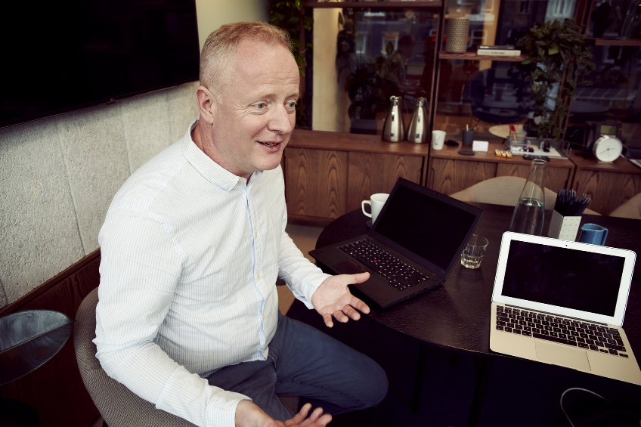

"The after-sales team supports customers who have problems with their motor vehicles after they bought them. At the moment the after-sales team is big and costing the business a lot of resource. I heard that we can use chatbots to take over some of the work that our after-sales support staff are doing.  I am interested in your thoughts.  Do you have any recommendations on whether I should make chatbots to replace them? Do you see any ethical concern with this approach?" He said.

You promised to send through an email outlining your thoughts.

You will be paired up with a team mate to work on the following Mission. Make sure you learn how to perform all the tasks in the Mission when you work alone.

## Your Mission for this week, should you accept it, is to perform the following tasks.

1. write an email that outlines your thoughts on ethical concerns of replacing after-sales staff with chatbots, and your recommendation to the manager.  You do not need to send the email. You will describe it in the Show and Tell. Remember it is a business email – pay attention to business email etiquettes. The following resource may help:
   * MANDATORY The 7 most pressing AI ethics concerns <https://kambria.io/blog/the-7-most-pressing-ethical-issues-in-artificial-intelligence/> (20 mins)
   * MANDATORY Ethical framework for AI <https://www2.deloitte.com/us/en/insights/focus/cognitive-technologies/design-principles-ethical-artificial-intelligence.html> (10 mins)
2. Perform specific tasks for your profession in the Appendices. You do not need to complete the tasks for all pathways. Only complete the tasks in the one Appendix relevant to your pathway.
3. Upload your work (presentation slides, documents or other files) to <https://mreadyhq.sharepoint.com/:f:/s/General/EjqjpNLsS_dHpKlTbuhyW7QBgZ2lczQZUBDWgObj7iIrSQ?e=20qwYY>. At the Show and Tell next week, (as a pair) talk everyone through the key points and decisions in your email. Also talk everyone through the profession-specific tasks you completed. Between the two of you, you have **10 minutes** in total to talk about all items. You can use PowerPoint slides, Sway or Prezi to help with your presentation.

## Appendix A – Tasks for UX Designers

If you are in the UX Designer pathway, complete the following tasks as part of the Mission:

1. Focus on the project to re-design the motor vehicle insurance purchasing experience. Identify a list of stakeholders you need to interview for the MV insurance UX redesign project. The following resource may help:
   * MANDATORY Stakeholder identification <https://www.youtube.com/watch?v=gc55hPIFW8w> (10 mins)
2. Then, write a list of interviewing questions for these 2 types of stakeholders: a customer, and for a MV insurance team staff.

* MANDATORY Fundamentals of User Interviews <https://www.skillshare.com/classes/User-Interviews-Fundamentals-for-Conducting-a-User-Interview/365833867> (20 mins)
* MANDATORY Asking great questions: <https://www.toptal.com/designers/product-design/design-thinking-great-questions> (20 mins)
* MANDATORY What questions a UX Designer should ask: <https://uxdesign.cc/questions-ux-designers-should-be-asking-bc9a6ba87a34> (20 mins)
* MANDATORY A great list of tips for user interviews and throughout the steps of creating a design <https://www.skillshare.com/classes/Design-Thinking-How-to-Use-Creative-Problem-Solving-for-Better-Design/1170532766> (1 hour)

## Appendix B – Tasks for Advanced Software Developers

If you are in the Advanced Software Developer pathway, complete the following tasks as part of the Mission:

1. Focus on the project to re-design the motor vehicle insurance purchasing experience. Identify a list of stakeholders you need to interview for the MV insurance UX redesign project. The following resource may help:
   * MANDATORY Stakeholder identification <https://www.youtube.com/watch?v=gc55hPIFW8w> (10 mins)
2. As a way to test feasibility, based on the FAQ page [<https://www.turners.co.nz/FAQs-Cars/>], build a prototype chatbot that answers questions about Online Auctions (just the “Online Auctions” sections of the FAQ, not all FAQs on the page). The following resources may help:
   * MANDATORY Guide to design a chatbot <https://www.dtelepathy.com/blog/design/lets-talk-about-text-a-chatbot-design-guide> (20 mins)
   * MANDATORY How to design a chatbot <https://medium.com/swlh/what-is-conversation-design-and-how-to-design-your-chatbot-3754f04ab1e7> (20 mins)
   * MANDATORY Building a Watson Chatbot <https://www.youtube.com/watch?v=MTCc4d-RXP0> (10 mins)
   * CHOOSE1 Building a Chatbot with Watson <https://developer.ibm.com/tutorials/create-your-first-assistant-powered-chatbot/> (1 hour)
   * CHOOSE1 Building a Chatbot using Microsoft Azure <https://stackify.com/create-azure-bot-service/> (1 hour)
   * RECOMMENDED Watson Virtual Assistant documentation <https://cloud.ibm.com/docs/services/assistant?topic=assistant-getting-started#getting-started>
3. Create a simple HTML page and integrate the chatbot with the page using API. The following resources may help:
   * CHOOSE 1 Integrating Azure chatbot to web page <https://docs.microsoft.com/en-us/azure/bot-service/bot-service-channel-connect-webchat?view=azure-bot-service-4.0> (2 hours)
   * CHOOSE 1 Integrating Watson chatbot to web page <https://cloud.ibm.com/docs/assistant?topic=assistant-deploy-web-chat> (2 hours)

## Appendix C – Tasks for Business Analysts

If you are in the Business Analyst pathway, complete the following tasks as part of the Mission:

1. Focus on the project to re-design the motor vehicle insurance purchasing experience. Identify a list of stakeholders you need to interview for the MV insurance UX redesign project. The following resource may help:
   * MANDATORY Stakeholder identification <https://www.youtube.com/watch?v=gc55hPIFW8w> (10 mins)
2. Then, write a list of interviewing questions for these 2 types of stakeholders: a customer, and for a MV insurance team staff.

* MANDATORY Fundamentals of User Interviews <https://www.skillshare.com/classes/User-Interviews-Fundamentals-for-Conducting-a-User-Interview/365833867> (20 mins)
* MANDATORY Asking great questions: <https://www.toptal.com/designers/product-design/design-thinking-great-questions> (20 mins)
* MANDATORY What questions a UX Designer should ask: <https://uxdesign.cc/questions-ux-designers-should-be-asking-bc9a6ba87a34> (20 mins)
* MANDATORY A great list of tips for user interviews and throughout the steps of creating a design <https://www.skillshare.com/classes/Design-Thinking-How-to-Use-Creative-Problem-Solving-for-Better-Design/1170532766> (1 hour)

## Appendix D – Tasks for Data Analysts

If you are in the Data Analyst pathway, complete the following tasks as part of the Mission:

1. You are given a task by the sales manager of Turners Car Auctions to find ways to improve sales of based on data. Identify the stakeholders for an initial interview. The following resources may help:
   * MANDATORY Stakeholder identification <https://www.youtube.com/watch?v=gc55hPIFW8w> (10 mins)
2. For each stakeholder, design at least 6 initial interviewing questions for a semi-structured interview. You can either use the same 6 questions or different questions for the interviews, depending on your needs. The following resources may help:
   * MANDATORY Fundamentals of User Interviews <https://www.skillshare.com/classes/User-Interviews-Fundamentals-for-Conducting-a-User-Interview/365833867> (20 mins)
   * MANDATORY Asking great questions: <https://www.toptal.com/designers/product-design/design-thinking-great-questions> (20 mins)
3. You are given current motor vehicle registration data for New Zealand [Mission 1 - Data Analyst Motor_Vehicle_Register.csv]. Perform analysis to find any insights you can, and describe how that impacts the business. Make suggestions on what the business should do. The following resources may help:
   * MANDATORY Statistics foundation: <https://www.youtube.com/watch?v=XbHeCL_8UhA> (1.5 hour)
   * RECOMMENDED Data Analysis in Excel <https://www.skillshare.com/classes/Microsoft-Excel-Data-Analytics-by-Real-World-Project/2135910568> (2.5 hours)